**ASSIGNMENT 2**

**Case Study: Implementation of SDLC Phases in the Development of an Online Cab Booking System**

**Project Overview**

**This case study analyzes the implementation of the Software Development Life Cycle (SDLC) phases in a real-world engineering project: the development of an online cab booking system. This system allows users to book rides, track drivers, and manage payments through a mobile application and web platform.**

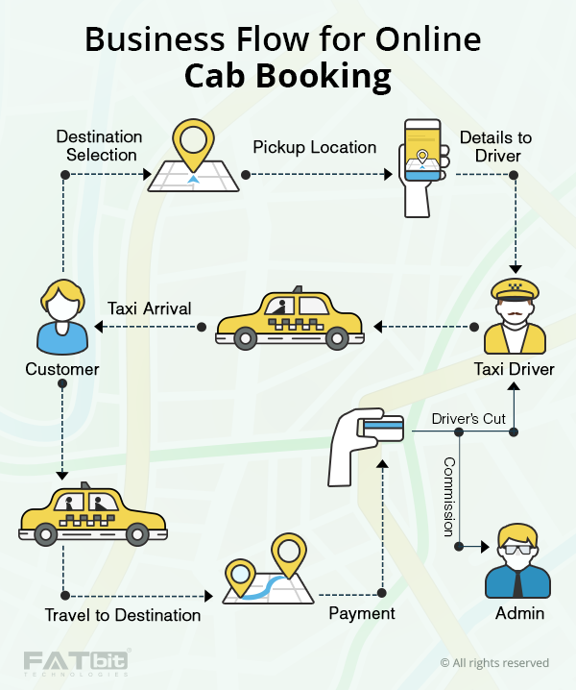

1. **Requirement Gathering**

**Activities:**

**Stakeholder Interviews: Conducted interviews with potential users, drivers, and cab companies to gather comprehensive requirements.**

**Surveys and Questionnaires: Distributed surveys to understand user preferences and pain points in existing cab booking services.**

**Requirement Documentation: Compiled a detailed requirement document covering functional requirements (e.g., booking, tracking, payment) and non-functional requirements (e.g., security, performance, scalability).**

**Outcome Contribution:**

**Effective requirement gathering ensured a clear understanding of user needs and business goals. This phase set a solid foundation for the project, ensuring that all subsequent phases were aligned with the stakeholders' expectations, reducing the risk of scope creep, and ensuring project success.**

**2. Design**

**Activities:**

**System Architecture Design: Developed a high-level architecture diagram illustrating the system's components, such as the user interface, backend services, database, and third-party APIs.**

**Database Design: Designed a relational database schema to manage user data, ride details, payment information, and driver profiles.**

**User Interface Design: Created wireframes and prototypes for the mobile and web applications to ensure a user-friendly experience.**

**Outcome Contribution:**

**A well-structured design phase provided a comprehensive blueprint for the system, facilitating smooth development and integration of various components. The detailed design helped identify potential issues early, improving overall system reliability and user satisfaction.**

**3. Implementation**

**Activities:**

**Coding: Developed the application using agile methodologies, breaking down tasks into sprints to manage progress and incorporate feedback iteratively.**

**API Integration: Integrated third-party services for maps, payment gateways, and SMS notifications.**

**Version Control: Utilized version control systems (e.g., Git) to manage code, track changes, and enable collaboration among developers.**

**Outcome Contribution:**

**Following a structured implementation plan ensured that the development was organized and efficient. Using agile methodologies allowed the team to adapt to changes and incorporate feedback quickly, resulting in a more refined product. Version control facilitated seamless collaboration and code management.**

**4. Testing**

**Activities:**

**Unit Testing: Performed unit tests on individual components to ensure they functioned correctly in isolation.**

**Integration Testing: Conducted integration tests to verify that different modules worked together seamlessly.**

**User Acceptance Testing (UAT): Invited a group of end-users to test the system in real-world scenarios and provide feedback on usability and performance.**

**Outcome Contribution:**

**Comprehensive testing identified and resolved issues before the system went live, ensuring a high-quality product. User Acceptance Testing provided valuable insights from actual users, leading to enhancements that improved user experience and system reliability.**

**5. Deployment**

**Activities:**

**Deployment Planning: Developed a detailed deployment plan, including schedules, resource allocation, and rollback strategies in case of failures.**

**Production Deployment: Launched the application to a live environment with continuous monitoring to ensure system stability.**

**Monitoring and Support: Set up monitoring tools to track system performance and user activities, ensuring quick resolution of any issues that arose post-deployment.**

**Outcome Contribution:**

**A well-executed deployment minimized downtime and ensured a smooth transition from development to operational status. Continuous monitoring allowed the team to promptly address any issues, ensuring a positive user experience from day one.**

**6. Maintenance**

**Activities:**

**Bug Fixes: Continuously monitored for bugs and issues, deploying fixes as needed.**

**Feature Updates: Released regular updates to add new features, improve performance, and enhance security.**

**Customer Support: Provided ongoing support to users through customer service channels, addressing their queries and concerns.**

**Outcome Contribution:**

**Ongoing maintenance ensured the system remained reliable, secure, and up-to-date with user needs. Regular updates and prompt issue resolution maintained user satisfaction and engagement, contributing to the system's long-term success.**

**Conclusion**

**The systematic implementation of SDLC phases in the development of the online cab booking system was crucial for its success. Each phase contributed significantly by ensuring thorough planning, design, implementation, testing, deployment, and continuous improvement. By adhering to the SDLC framework, the project team delivered a high-quality, user-centric product that met market demands and exceeded user expectations.**